**First Web App in Azure**

1. To Create a Web App go to Create Resource Group --> Web App.
2. Select the Subscription and select the existing Resource Group or create a new Resource Group.
3. Name the Web App and select the Runtime stack.
4. Select the Region.

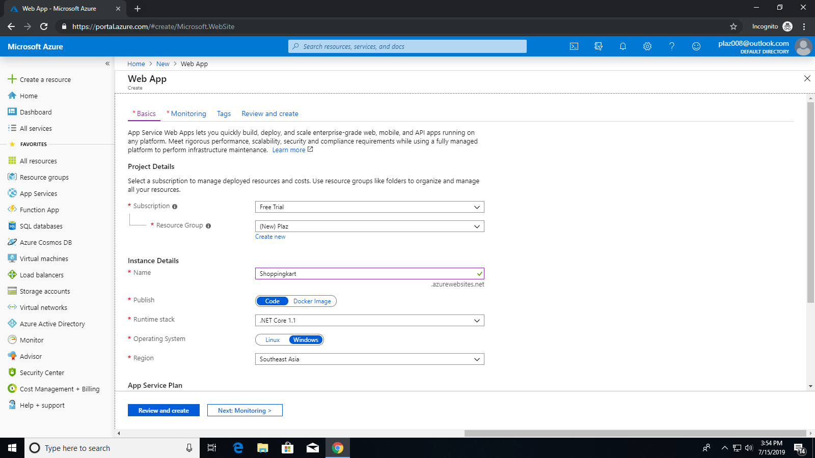

1. Select the size, etc.

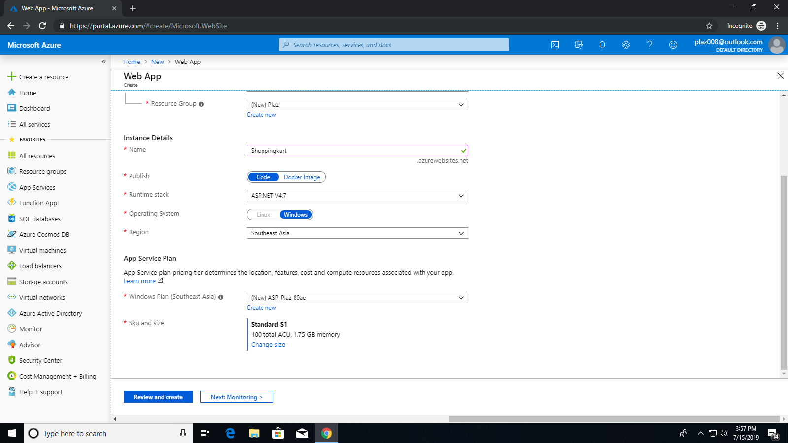

1. Click on Review and Create.

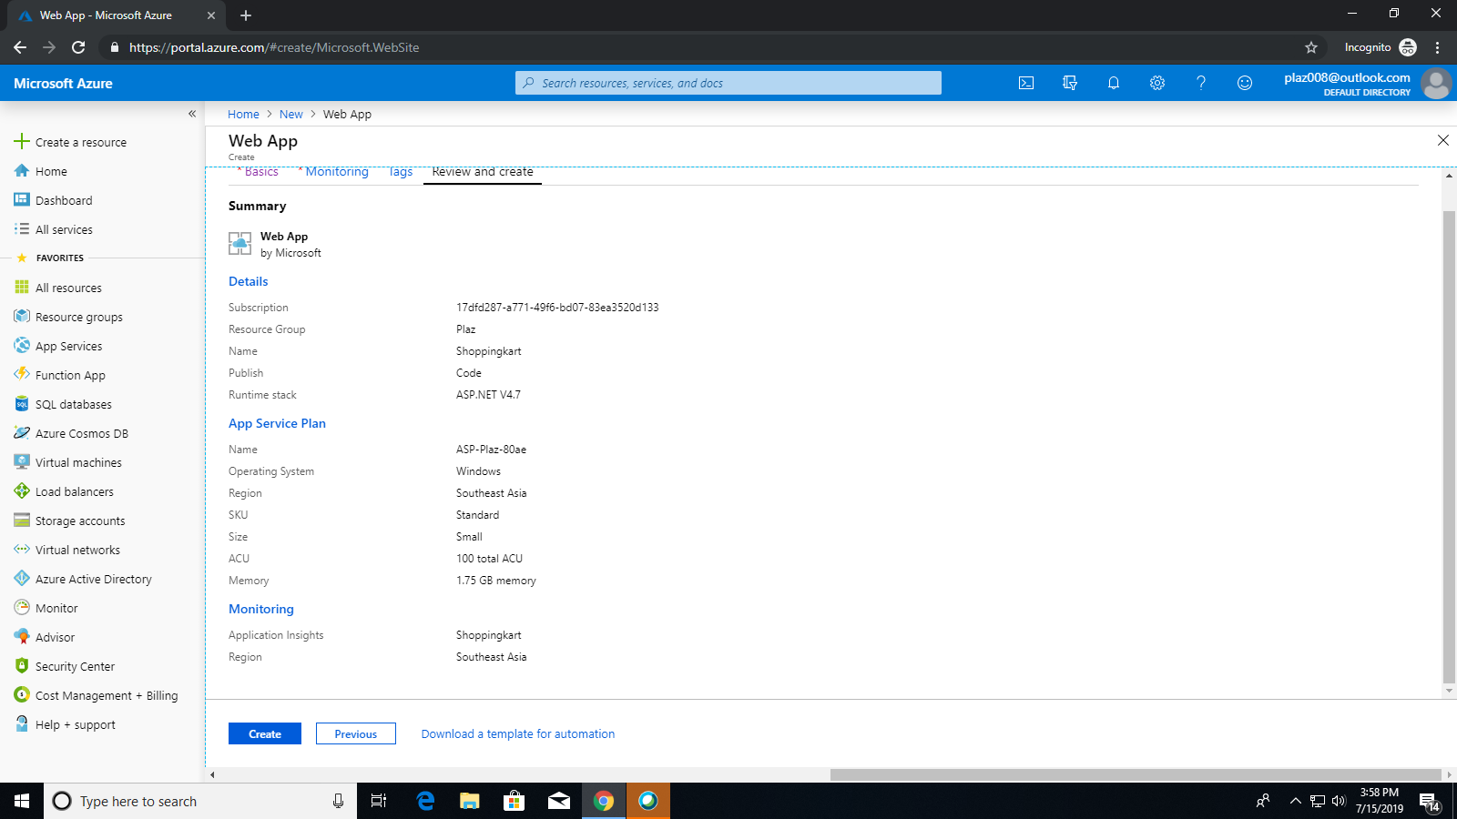

1. After reviewing click on Create.



1. Once the Web App is created click on the link present inside the Web App.

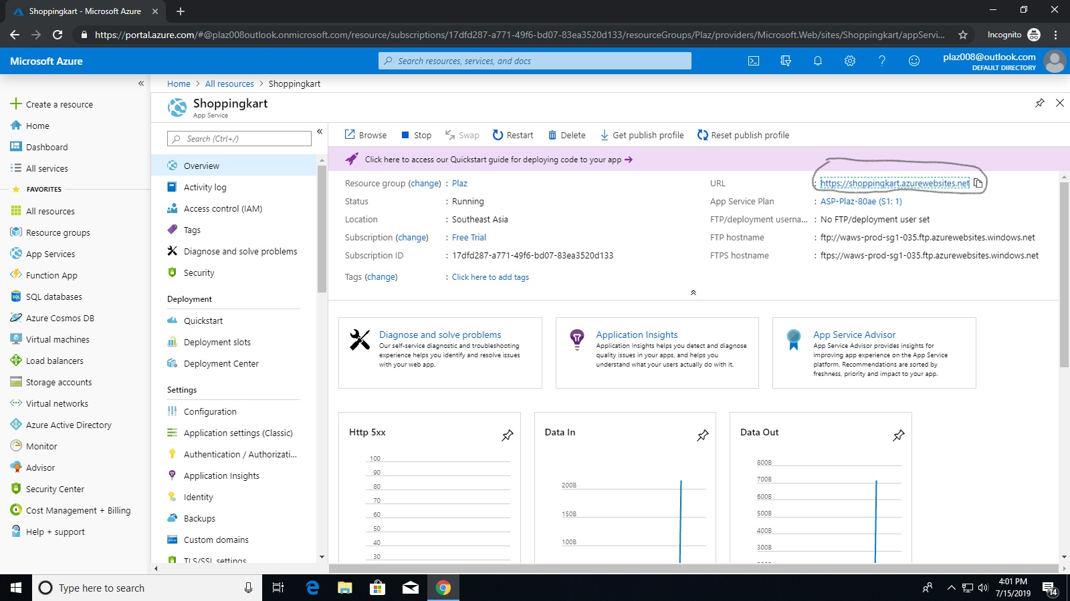

1. View the Web App that is created.

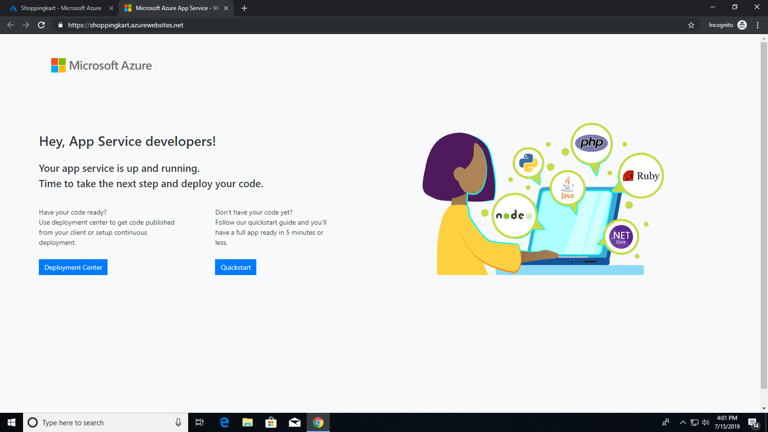

1. Create a ASP.NET Web Application project in Visual Studio.

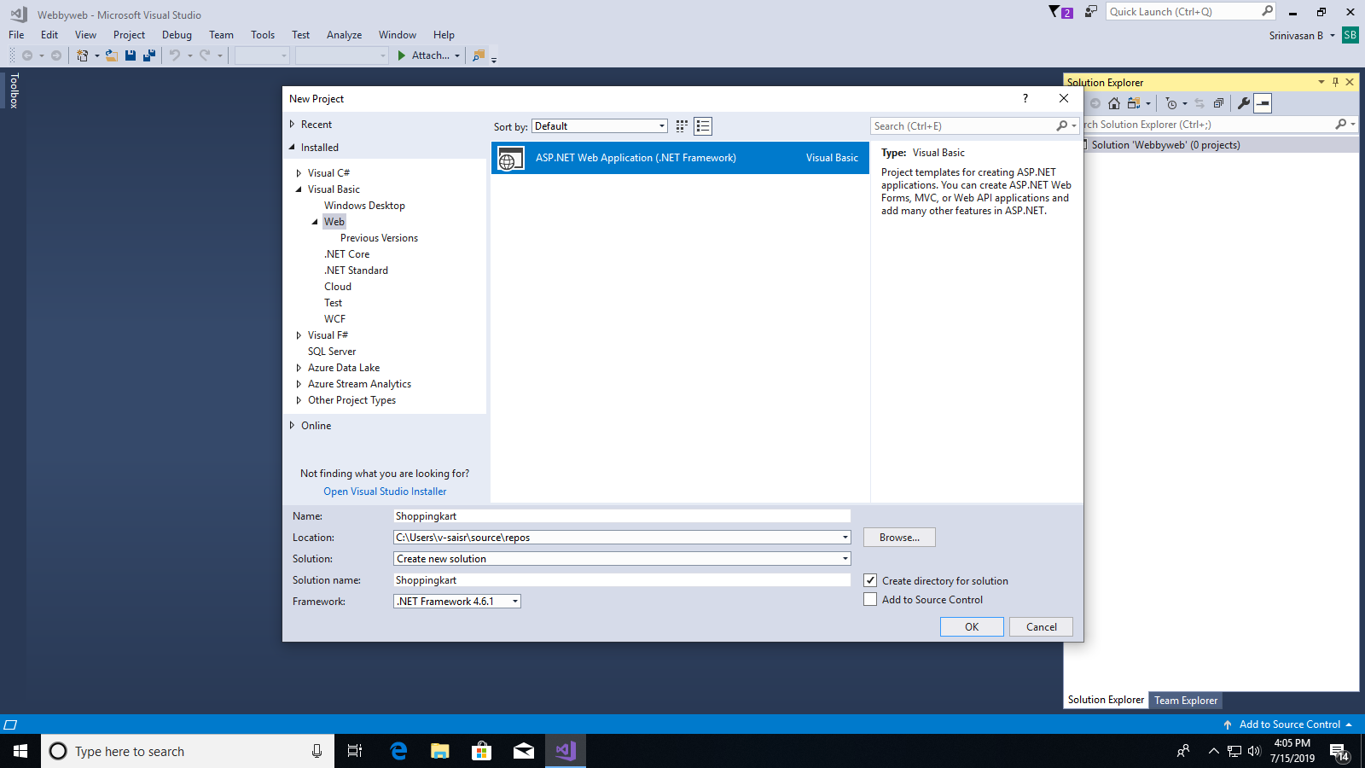

1. Publish your Code to the Web App that is created in Azure by logging-in to the azure account in Visual Studio.

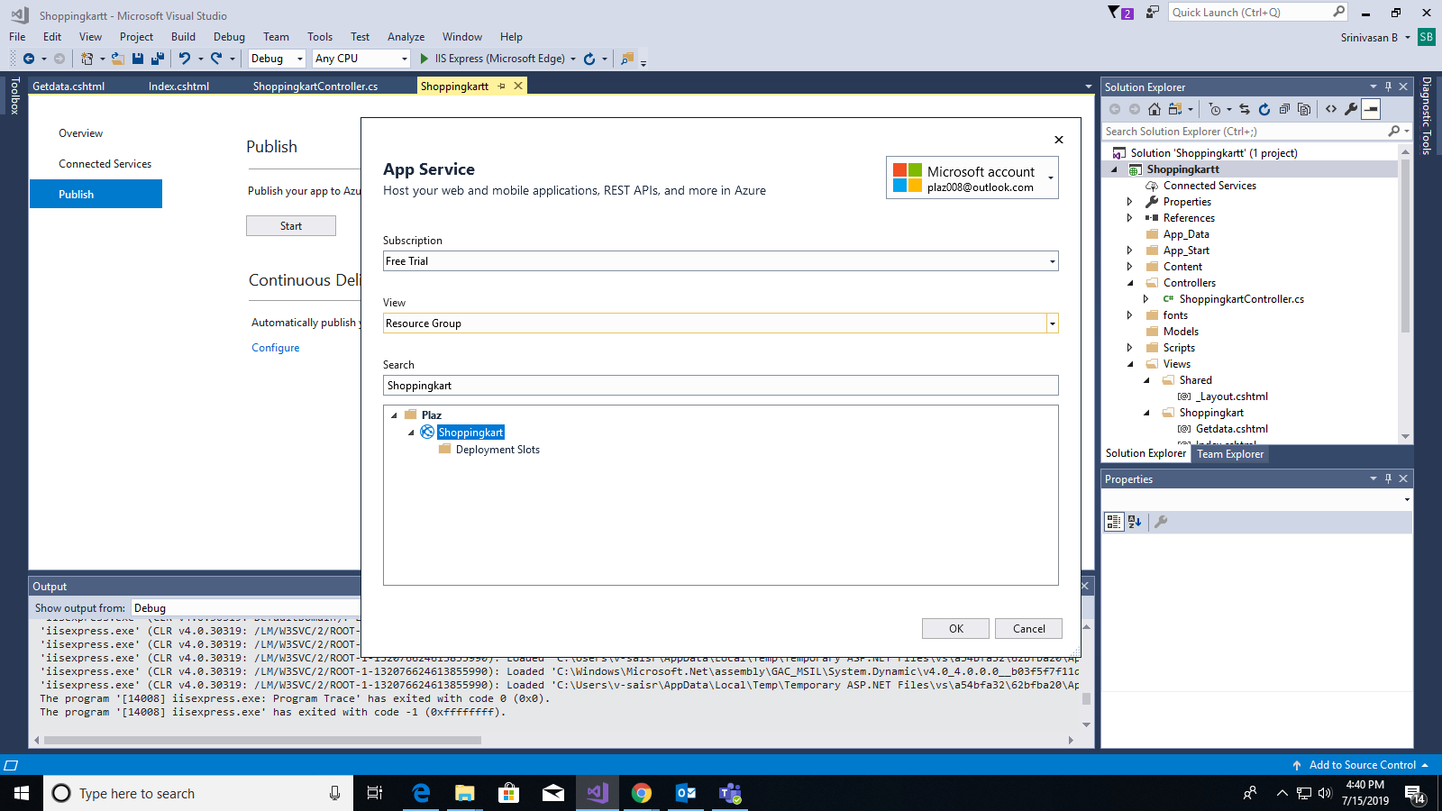

1. Refresh the Web App link you created in Azure portal the changes should be reflected.

